Bulletin 1 of Informational Center of Indigenous people of Khakass Republic “Aran Chula”

“… The training course was a great experience for me “
My name is Anastasia Yarinskaya, I live in Novokuznetsk, Kemerovo Oblast. I have been a member of group “Akh Kun” under the Shorian Culture Center “Aba Tura” since 2003. Our center will be 10 in October. The center aims to preserve and develop Shorian language and culture. I have first-hand knowledge of problems my people face trying to preserve their original culture, language, customs and traditional living. That is why when O.N. Tenesheva, head of the center offered me to take part in the training course on the rights of indigenous peoples in Abakan I did not hesitate to agree.
The training course was arranged by Khakass center of Interregional public organization “L'auravetl'an Information and Education Network of Indigenous Peoples” and it was a great experience for me.
During 3 weeks we studied international, federal and regional laws concerning indigenous peoples. We also discussed problems of indigenous peoples and ways of their solution in detail.
At the request of interns special attention was paid to the issue of preservation and development of Shorian language and culture. Teaching of native language in places of compact living of small-numbered indigenous peoples is provided for by law but in practice this law cannot be implemented everywhere. In Khakassia, for example, such law on small-numbered indigenous peoples has not been passed yet and there is no word of language in the draft law. That is why authorities have no means to finance optional Shorian classes never mind include them into compulsory subjects. For all that, youth cease to show interest to study of their native language.
Before our meeting with Mikhail A. Sarazhakov, chairperson of the Committee of Local Self-Government, Public Associations and Interethnic Relations of the Supreme Soviet of Khakass Republic, we prepared amendments to this law in the name of Shorian communities “Altyn Kyun” and “Tamyr” which representatives took part in the training course with us. This law will not be effective without more precise definition and a language clause!
We also examined questions of establishment of small-numbered indigenous peoples’ communities, their activities and problems they face. The problem of taiga’s preservation is the most urgent in our opinion. Woods are being cruelly cut down and there is no question of reforestation. And traditional economic activities of Shors are inseparably linked with taiga and taiga rivers. Hunting, fishing and gathering of wild plants will soon become impossible under such conditions.
Besides the above mentioned Committeeof the Supreme Soviet of Khakass Republic we also visited other bodies of legislative and executive power of Khakassia. Meetings with Viktor S. Okayomov, representative of the State Committee of Environment Protection of the Russian Federation, and Yulia V. Kostyakova, deputy minister of culture of Khakass Republic, seemed to be most memorable and useful.
I was a little disappointed with the round table on indigenous issues in Matur Settlement. We found it somewhat formal and many important problems were simply not discussed.
There were many other interesting meetings with representatives of other public organizations, with the historian of the Khakass scientific and research institute of history, language and literature and with correspondents of Khakass mass-media. Our visit to Khakass Theater “Chitigen” was both useful and interesting.
I want to thank everyone who arranged the training course and especially Lev. N. Nerbyshev and Natalya V. Korosteleva. We acquired a lot of useful information and were also filled with courage, positive news and wish to participate in life of our people and to preserve its culture and unique identity.
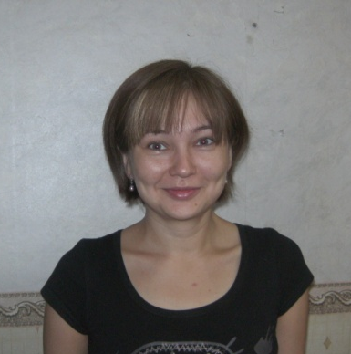

Anastasia Yarinskaya

My father often tells me - “You are a descendant of the great people!” And he tells me about history of Khakassia. As I listen, I see boundless steppes, dense taiga and numerous herds of horses. According to my father people knew nothing of poverty and wealth. My people were called “izep chokh chon” (people without pockets) in ancient eposes.
Rich and fertile land of Khakassia always attracted many peoples. It was probably this land that Alexander of Macedon called Hyperborea. Maybe Rerikh should search for Belovovdie here.
In the course of centuries many peoples lived on the territory of Khakassia and left their marks in heroic epics and tumuli. Today anyone can tell you that Khakassia is an archaeological Mecca of Russia. It is here where the first musical instrument – reed pipe – was found. It is here where Russian archaeology arose.
Today indigenous peoples of Khakassia – Khakasses and Shorians – keep and adhere to customs and traditions that ancient Scythians, Huns, Dinlins, Samoyedic people and Kyrgyzes left us. We are descendants of Irenek Khan, Hansa-pik and Bars-pik and we have to pass on popular wisdom to our future generations.
We can preserve this wealth in a variety of ways, such as: transmission from generation to generation, recording in print and information storage in computers, etc. But this is not enough. Thousands of tourists visit our land every year. Many of them come to marvel at our nature and to feel a sense of history. But some of them come to commit vandalism and crude disregard of another culture. I think we should struggle with such people by all legal means.
Russian legislation allows Shorians to create traditional land use areas as they are small-numbered indigenous people. This is one of legal ways to protect our nature and monuments from vandalism. It is to be regretted that Russian legislation tries to preserve only those peoples which population cannot be increased according to modern society. Khakasses are on the verge: their population amounts to more than 50.000 but it is less than 70.000 already. Khakasses still have the chance. But the law does not protect against extinction. There are no legal ways in Russian law for such small peoples to avoid small number.
International law does not discriminate between small-numbered indigenous and indigenous peoples. This discrimination exists only in the Russian Federation. But even laws for small-numbered indigenous peoples exist only in form. These peoples have to fight for their rights even if they are constitutional ones.
The most important thing today is to create an information base. It is necessary to establish centers where any representative of indigenous peoples whether small-numbered or not can obtain legal knowledge. And then everything depends upon every man, every people, all of us. If we silently sit and wait for land, forest and other natural resources we will get nowhere. We must require everything indigenous peoples achieved in the whole world. We must make authorities collaborate with us honestly.
I am very glad I took the training course. And I am proud of having participated in the first training course of that kind in Khakassia.
Our task is to advance in acquired knowledge, impart it to other people and use it to develop our society.
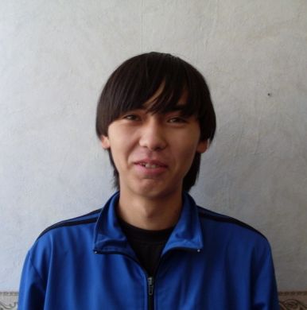
Mikhail Nerbyshev

Community is a Wise Thing
I am Natalya Arkadyevna Tenesheva. I am a methodologist of Shorian Culture Center “Aba-Tura” in Novokuznetsk, Kemerovo Oblast.
I realized fully that a community is a wise thing after I took the three-week training course in the field of human rights and rights of indigenous peoples of the Russian Federation, organized in Abakan, communicated with people and acquired a lot of useful information including that on the history of settlement and formation of Khakass people (Valery Karpovich Chertykov, research officer of Khakass scientific and research institute of history, language and literature, lectured on that).
Historically, peasants used to live in communities in Russia. They helped each other in work and bore mutual responsibility. It was the only way to survive in our climatic conditions.
During perestroika kolkhozes that replaced communities in soviet time were destroyed. And what did we get instead of them? Individual farms did not make roots and only a few farms were successful. The flight of time proved that communities are more viable in rural areas under present-day conditions too.
At present they establish communities in places of compact living of small-numbered indigenous peoples. A territory community of small-numbered indigenous peoples is a team where people are interested in traditional trades and extension of economic ties as well as in cultural activities. A community gives the possibility to preserve and develop national culture, art, traditions and customs and national language. A community is a key factor that can help people protect their rights and territories where they lived and conducted traditional economic activities for centuries.
A community (kolkhoz) used to be a form of government both under tsars and in soviet times but government often interfered in communities and tried to govern life and relations within the community. Now we have laws but at the same time we cannot turn a community into a really independent unit of economic and cultural life.
Old Believers’ communities that are Shors’ neighbours in Kemerovo Oblast may be an example of effective community activities these days. They keep to their traditional way of life and at the same time they participate in the life of the country at large.
At present communities have broad prospects - they may not only develop traditional economic activities but also develop new ones such as ecological tourism, for example, that can bring an income. It is important to build relationships within the community so as to make it a real team: what goes around comes around.
So I address to you, dear reader! If you have the sense that you can and want to live on the land and lead traditional way of life of your people, if you are not afraid of work and you have managerial abilities so do create communities which will promote your stability and sustainable development!

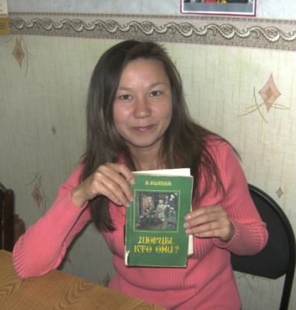
Natalya Tenesheva

I am from Anchul Settlement, a scenic part of Khakassia embosomed in mountains and taiga. I have always been faithful to my native land, because it is the most beautiful place in the world: there are still wild primeval corners; the water in our River Tashtyp is so clear and transparent that sometimes you can watch fish swimming. I love my land and I take pride in it. And I am proud of my people and I feel to be a part of it.
Shors used to be good fishers and hunters since earliest times. And I have believed that communication with nature was my all in all. It is good to have a day out and follow unbeaten taiga paths with an arm or fish on the river.
Our nature like a mother gives a chance to rest from noise and fuss as well as it provides my people with everything necessary. Traditional Shorian trades are inseparably linked with forest. They are fishing and hunting as well as gathering of wild plants, wild-honey farming and bee keeping, wood utensils and souvenirs manufacturing. However many things have changed because of “civilization” in these parts, and not all the changes were for the better. Forests are cut down, rivers are polluted, commercially important fish are disappearing, and poachers kill taiga animals beyond measure. There is an attack against the traditional living and land use areas of Shorians.
It so fell out that only at a mature age I finally realized that carefree life had passed and time is ripe for defending on legal grounds our territories and what we live on. That is why we established a territory community “Tamyr” in our settlement.
It is always difficult to break new grounds. We do not know everything and we do not know how to do many things. However there are organizations and people in Khakassia who gave us their helping hand. They are first of all the Ministry of National and Territorial Policy of the Khakass Republic and its minister Nadezhda P. Balakhchina and “Aran Chula” Information Center of Indigenous Peoples of Khakass Republic under the chairmanship of Lev. N. Nerbyshev.
Thanks to Lev. N. Nerbyshev I (as the chairman of the Shorian community) became convinced that one should start from study of laws concerning small-numbered indigenous peoples. That is really so – how can you protect the rights if you have only a vague idea of them? That is why the seminar Information Center “Aran Chula” invited me to attend in May and especially the three-week training course organized by Kuzbass-Khakass Center of LIENIP were extremely necessary and very useful. We talked a lot of international and Russian legislation concerning small-numbered indigenous peoples, studied legislative acts of Khakass Republic and Kemerovo Oblast, compared and discussed what works and what does not and what to do to make it work. We even prepared our amendments to small-numbered indigenous people’s act of Khakassia that was going to be debated at the Supreme Soviet of Khakass Republic in several days after the training course. There were a lot of interesting and useful meetings. During practical training each of us drew up a project to apply for a grant and defended it in front of other interns.
Empowered with knowledge and skills we went home to continue with protection of our people’s right to traditional living, right to preserve and develop our language, our original culture, to revive customs and traditional trades – everything my people were strong in for centuries.
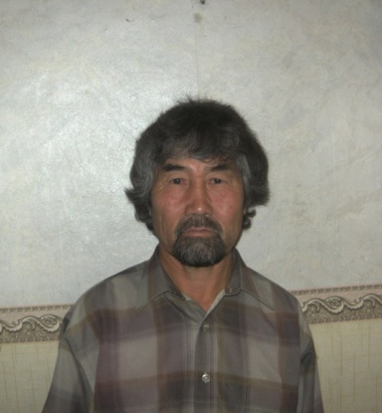
Boris Shulbaev

My Grandfather is Shorian
I would like to tell about my grandfather, his name is Nikolai Nikolayevich Kiskorov. He was born on 20 July 1940 in Porushka (Ust-Anzas Soviet of the settlement). He was the eldest child that is why he got a job when he was 12. Wherever he worked he never forgot his favourite pursuits – hunting and fishing. When he moved to Khakassia he got a job in the forestry as a staff hunter, then he became a gamekeeper. The job gave him comfort. It was a familiar and native occupation since childhood. He simply was Shorian. To go to taiga it was necessary to make national skis, a hunter's whistle for hazel-grouse, etc. Grandfather did them all himself. When he had a rest in taiga he carved wooden spoons. He could cook Shorian meat dumplings. He had the gift for turning his hand to anything. When he was back from taiga it seemed as if he had visited a resort. He was cheerful and not empty-handed but with meat and skins as that were his earnings to keep his family. He knew medicinal herbs. He brought two little bear cubs from taiga one day as their young mother left them. We had to feed milk and fish to them. The bear cubs gamboled and bathed in the river like children. Grandfather brought them up, the cubs did as he told them. When they grew up they began to run into the forest but then they returned home. Later on their visits to home grew few and finally they had gone forever. They were wild beasts, they had instincts and they stunted and perished without taiga. The same happens with a human. The bond with nature provides a human with many things: physical strength, endurance, reasonable approach to definite aim and it teaches him to be a good master of taiga. It is given them by nature. This is their way of life but it is becoming forgotten and dying out. We should see if anything could be done to make this people live, prosper and teach us their traditional living.
Tatyana Oreshkova

